Lesson 1: General Concepts of Pressure and Wind: ***Oversimplification of concept: Fluid flows downhill.***

**1. Overview of Atmospheric Pressure**

What is Pressure? What is Wind and how is it generated within large weather systems? How is wind related to atmospheric pressure?

Atmospheric Pressure is the force exerted on a surface by the air above it as gravity pulls it to Earth. The pressure exerted by the weight of the atmosphere, which at sea level has a mean value of 101,325 pascals (roughly 14.6959 pounds per square inch). Atmospheric pressure is commonly measured with a barometer. In a barometer, a column of mercury in a glass tube rises or falls as the weight of the atmosphere changes.

Wind is defined as the perceptible natural movement of the air, especially in the form of a current of air blowing from a particular direction. In meteorology, winds are often referred to according to their strength, and the direction from which the wind is blowing. Short bursts of high-speed wind are termed gusts. Strong winds of intermediate duration (around one minute) are termed squalls. Long-duration winds have various names associated with their average strength, such as breeze, gale, storm, and hurricane. Wind occurs on a range of scales, from thunderstorm flows lasting tens of minutes, to local breezes generated by heating of land surfaces and lasting a few hours, to global winds resulting from the difference in absorption of solar energy between the climate zones on Earth.

Wind is caused by differences in the atmospheric pressure. When a difference in atmospheric pressure exists, air moves from the higher to the lower pressure area, resulting in winds of various speeds. On a rotating planet, air will also be deflected by the Coriolis effect, except exactly on the equator.

**2. Wind and Pressure**

What determines the atmospheric pressure at a location? Is it the mass of air in the atmospheric column? Is it the density of the air? Is it the temperature of the air column? How is wind related to atmospheric pressure?

Wind is moving air and is caused by differences in air pressure within our atmosphere. Air under high pressure moves toward areas of low pressure. The greater the difference in pressure, the faster the air flows. This occurs because the atmosphere is not uniformly distributed around the earth. Air will leave one location to accumulate in another. Those spatial differences cause atmospheric pressure differences at ground level which induces a net force that accelerates the air, thus setting it in motion and creating wind.

High pressure is associated with sinking air, and low pressure is associated with rising air. ... The slightly inward moving air in low pressure causes air to converge and since it can't move downward due to the surface, the air is forced upward, leading to condensation and precipitation.

**3. Pressure and Wind Maps**

How do we construct a pressure map from pressure measurements? What can we learn from this data? How are pressure and temperature patterns related?

Color Scales, Pressure Scales, Distribution of Pressure Pattern Recognition, Contouring

General rules: An Isobar is a line on a map connecting points having the same atmospheric pressure at a given time or on average over a given period. The pressure should decrease on one side of the isobar and increase on the other.

If a station indicates a value that corresponds to a specific isobar then that isobar should pass through that station If an isobar doesn’t exactly match a station the isobar should be drawn equidistant between two stations.

Isobars around Highs are generally more widely spaced than those around lows.

**4. Pressure and Wind at Different Atmospheric levels**

What are the effects of the decrease in atmospheric pressure and altitude?

Most weather phenomena occur in the lowest level of the atmosphere, the troposphere, just below the stratosphere.

In general, air pressure and density decrease with altitude in the atmosphere. However, temperature has a more complicated profile with altitude, and may remain relatively constant or even increase with altitude in some regions (see the temperature section, below). Because the general pattern of the temperature/altitude profile, or lapse rate, is constant and measurable by means of instrumented balloon soundings, the temperature behavior provides a useful metric to distinguish atmospheric layers. In this way, Earth's atmosphere can be divided (called atmospheric stratification) into five main layers. Excluding the exosphere, the atmosphere has four primary layers, which are the troposphere, stratosphere, mesosphere, and thermosphere. From highest to lowest, the five main layers are:

Exosphere: 700 to 10,000 km (440 to 6,200 miles)

Thermosphere: 80 to 700 km (50 to 440 miles)

Mesosphere: 50 to 80 km (31 to 50 miles)

Stratosphere: 12 to 50 km (7 to 31 miles)

**Troposphere: 0 to 12 km (0 to 7 miles) 🡨 Most Weather Occurs Here**

Common Pressure Levels and Altitudes:

Level Altitude(ft) Altitude(m)

1000 MB 364 ft 111 m

925 MB 2,498 ft 762 m

850 MB 4,781 ft 1,458 m

700 MB 9,882 ft 3,013 m

500 MB 18,289 ft 5,576 m

400 MB 23,574 ft 7,187 m

300 MB 30,065 ft 9,166 m

250 MB 33,999 ft 10,366 m

200 MB 38,662 ft 11,787 m

5. 3D Representation of Pressure/Wind

Using Virtual Reality to Visualize Atmospheric Conditions and Phenomena

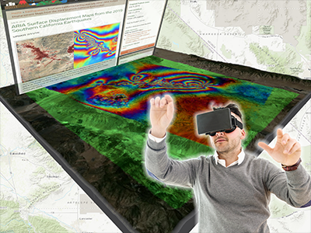

**Lesson Plan 1 : Overview of Atmospheric Pressure**

**Objectives:** What is Pressure? What is Wind and how is it generated within large weather systems? How is wind related to atmospheric pressure? Air has certain properties: takes up space, has mass and volume; therefore it exerts pressure. The symbols H and L on a weather map represent areas of high and low pressure. The isobars represent areas of equal pressure.

**Common Core Standards:** Molecules, Pressure, Wind

E.7.9A Students will demonstrate an understanding of how complex changes in the movement and patterns of air and water molecules caused by the sun, winds, landforms, ocean temperatures, and currents in the atmosphere are major determinants of local and global weather patterns.

E.7.9A.1 Analyze and interpret weather patterns from various regions to differentiate between weather and climate.

E.7.9A.2 Analyze evidence to explain the weather conditions that result from the relationship between the movement of water and air masses.

E.8.9B.1 Research and map various types of natural hazards to determine their impact on society.

PHS.8.3 Relate thermal energy transfer to real world applications of conduction (e.g., quenching metals), convection (e.g., movement of air masses/weather/plate tectonics), and radiation (e.g., electromagnetic).

ESS.3.5 Analyze and interpret weather data using maps and global weather systems to explain and communicate the relationships among air masses, pressure systems, and frontal boundaries.

**Pacing:** Week Long (5) 45 minute lessons

**WARM UP: Bill Nye Atmospheric Pressure:** <https://www.youtube.com/watch?v=QeAp3CuGjk8>

**TEACH:**

What is Pressure? What is Wind and how is it generated within large weather systems? How is wind related to atmospheric pressure?

Atmospheric Pressure is the force exerted on a surface by the air above it as gravity pulls it to Earth. The pressure exerted by the weight of the atmosphere, which at sea level has a mean value of 101,325 pascals (roughly 14.6959 pounds per square inch). Atmospheric pressure is commonly measured with a barometer. In a barometer, a column of mercury in a glass tube rises or falls as the weight of the atmosphere changes.

Wind is defined as the perceptible natural movement of the air, especially in the form of a current of air blowing from a particular direction. In meteorology, winds are often referred to according to their strength, and the direction from which the wind is blowing. Short bursts of high-speed wind are termed gusts. Strong winds of intermediate duration (around one minute) are termed squalls. Long-duration winds have various names associated with their average strength, such as breeze, gale, storm, and hurricane. Wind occurs on a range of scales, from thunderstorm flows lasting tens of minutes, to local breezes generated by heating of land surfaces and lasting a few hours, to global winds resulting from the difference in absorption of solar energy between the climate zones on Earth.

Wind is caused by differences in the atmospheric pressure. When a difference in atmospheric pressure exists, air moves from the higher to the lower pressure area, resulting in winds of various speeds. On a rotating planet, air will also be deflected by the Coriolis effect, except exactly on the equator.

**Powerpoint Presentations**

**Alternate Opener: Using Twister.Com on classroom devices, observe current weather models for your region.**

**REACHING ALL LEARNERS – Differentiated Instruction for students with**

**Developing Knowledge:** Students will be communicating and developing vocabulary.

**On-level Knowledge:** Students will compare, and contrast weather conditions associated with areas of high and low pressure.

**Advanced Knowledge:** Students will infer that since air has mass and volume, it must therefore exert pressure.

**English (ESL) Language Development Multilingual Glossary**

**Hace calor = It is hot**

**Hace frío = It is cold**

**Hace fresco = It is cool**

**Hace buen tiempo = The weather is nice**

**Hace mal tiempo = The weather is bad**

**Cooperative Learning: Share your results with your neighbor while critiquing each other’s models and understanding. Understand that more eyes on a project make for a better outcome.**

**Reteach - Success for Every Learner**

**Questioning Strategies**

**To actively involve students in the lesson.**

**To increase motivation or interest.**

**To evaluate students' preparation.**

**To check on completion of work.**

**To develop critical thinking skills.**

**To review previous lessons.**

**To nurture insights.**

**Communicating Concepts:** Air pressure can impact athletic performance. There is less resistance from the atmosphere at high altitudes, which means that athletes has the potential to jump higher and run faster. However, at higher altitudes there is less oxygen available to the athletes body, therefore causing reduced performance but potentially improved endurance when the athlete returns to lower elevations.

**PRACTICE AND APPLY**

**Vocabulary Exercises:** Molecules, Pressure, Wind

**ASSESSMENT and Quiz**

**Lesson Plan 2 : Wind and Pressure**

**Objectives:** What determines the atmospheric pressure at a location? Is it the mass of air in the atmospheric column? Is it the density of the air? Is it the temperature of the air column? How is wind related to atmospheric pressure?

**Common Core Standards:** Pressure, Force, Balance of Forces, Equilibrium, Stability, Buoyancy, Weight, Buoyant Force.

E.7.9A Students will demonstrate an understanding of how complex changes in the movement and patterns of air and water molecules caused by the sun, winds, landforms, ocean temperatures, and currents in the atmosphere are major determinants of local and global weather patterns.

E.7.9A.1 Analyze and interpret weather patterns from various regions to differentiate between weather and climate.

E.7.9A.2 Analyze evidence to explain the weather conditions that result from the relationship between the movement of water and air masses.

E.8.9B.1 Research and map various types of natural hazards to determine their impact on society.

PHS.8.3 Relate thermal energy transfer to real world applications of conduction (e.g., quenching metals), convection (e.g., movement of air masses/weather/plate tectonics), and radiation (e.g., electromagnetic).

ESS.3.5 Analyze and interpret weather data using maps and global weather systems to explain and communicate the relationships among air masses, pressure systems, and frontal boundaries.

**Pacing:** Week Long (5) 45 minute lessons

**WARM UP:** Why does air move from high pressure to low pressure?

**TEACH:**

What determines the atmospheric pressure at a location? Is it the mass of air in the atmospheric column? Is it the density of the air? Is it the temperature of the air column? How is wind related to atmospheric pressure?

Wind is moving air and is caused by differences in air pressure within our atmosphere. Air under high pressure moves toward areas of low pressure. The greater the difference in pressure, the faster the air flows. This occurs because the atmosphere is not uniformly distributed around the earth. Air will leave one location to accumulate in another. Those spatial differences cause atmospheric pressure differences at ground level which induces a net force that accelerates the air, thus setting it in motion and creating wind.

High pressure is associated with sinking air, and low pressure is associated with rising air. ... The slightly inward moving air in low pressure causes air to converge and since it can't move downward due to the surface, the air is forced upward, leading to condensation and precipitation.

**Powerpoint Presentations**

**Alternate Opener: Using Twister.Com on classroom devices, observe current weather models for your region.**

**REACHING ALL LEARNERS – Differentiated Instruction for students with**

**Developing Knowledge:** Students will be communicating and developing vocabulary

**On-level Knowledge:** Students will make observations about the typ of weather associated with different wind speeds and directions.

**Advanced Knowledge:** Students will be using numbers during the process of collecting, recording, analyzing and interpreting data, They will infer that wind speed and direction affect weather systems.

**English (ESL) Language Development Multilingual Glossary**

**Está nublado = It is cloudy**

**Está soleado = It is sunny**

**Está despejado = It is clear**

**Está ventoso = It is windy**

**Está tormentoso = It is stormy**

**Está lloviendo = It is raining**

**Está nevando = It is snowing**

**Cooperative Learning: Share your results with your neighbor while critiquing each other’s models and understanding. Understand that more eyes on a project make for a better outcome.**

**Reteach - Success for Every Learner**

**Questioning Strategies**

**To actively involve students in the lesson.**

**To increase motivation or interest.**

**To evaluate students' preparation.**

**To check on completion of work.**

**To develop critical thinking skills.**

**To review previous lessons.**

**To nurture insights.**

**Communicating Concepts:** Many local wind systems have their own names. A list/link <https://ggweather.com/winds.html> is provided. Discuss potential impacts of some of the more well know surface winds (Chinooks).

**PRACTICE AND APPLY**

**Vocabulary Exercises:** Pressure, Force, Balance of Forces, Equilibrium, Stability, Buoyancy, Weight, Buoyant Force.

**ASSESSMENT and Quiz**

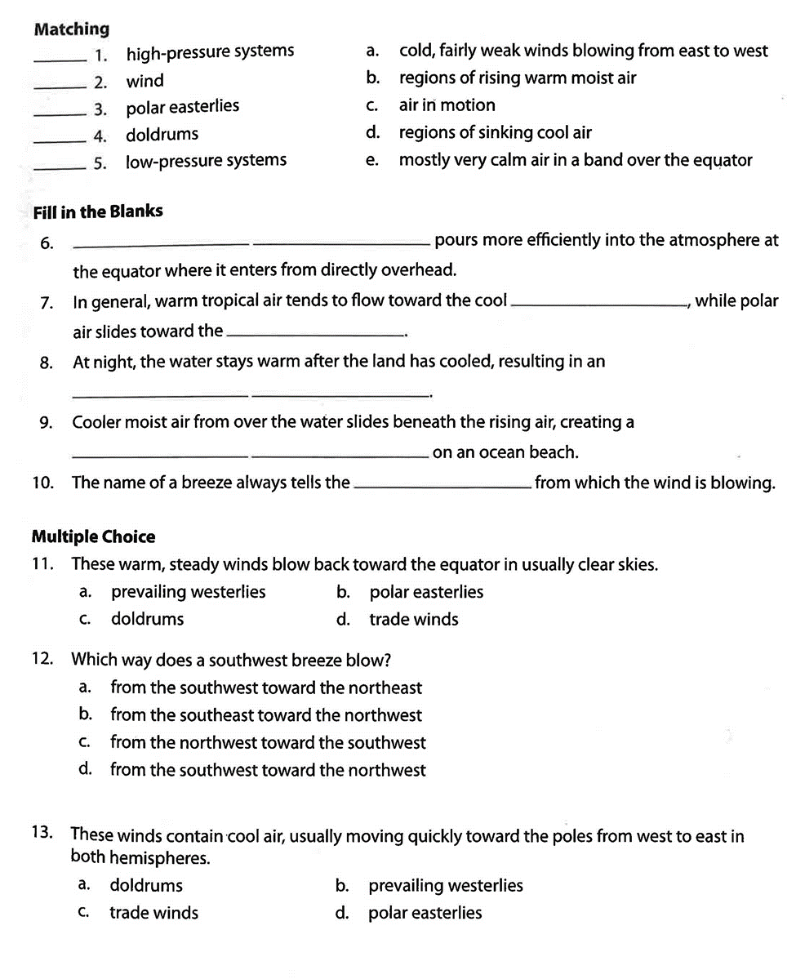

**Lesson Plan 3 : Pressure and Wind Maps**

**Objectives:** How do we construct a pressure map from pressure measurements? What can we learn from this data? How are pressure and temperature patterns related?

**Common Core Standards:** Pressure Maps, Isobars, High and Low Pressure. Color Scales, Pressure Scales, Distribution of Pressure Pattern Recognition, Contouring

E.7.9A Students will demonstrate an understanding of how complex changes in the movement and patterns of air and water molecules caused by the sun, winds, landforms, ocean temperatures, and currents in the atmosphere are major determinants of local and global weather patterns.

E.7.9A.1 Analyze and interpret weather patterns from various regions to differentiate between weather and climate.

E.7.9A.2 Analyze evidence to explain the weather conditions that result from the relationship between the movement of water and air masses.

E.8.9B.1 Research and map various types of natural hazards to determine their impact on society.

PHS.8.3 Relate thermal energy transfer to real world applications of conduction (e.g., quenching metals), convection (e.g., movement of air masses/weather/plate tectonics), and radiation (e.g., electromagnetic).

ESS.3.5 Analyze and interpret weather data using maps and global weather systems to explain and communicate the relationships among air masses, pressure systems, and frontal boundaries.

**Pacing:** Week Long (5) 45 minute lessons

**WARM UP:** What is the relationship between air pressure and wind?

**TEACH:**

How do we construct a pressure map from pressure measurements? What can we learn from this data? How are pressure and temperature patterns related?

Color Scales, Pressure Scales, Distribution of Pressure Pattern Recognition, Contouring

General rules: An Isobar is a line on a map connecting points having the same atmospheric pressure at a given time or on average over a given period. The pressure should decrease on one side of the isobar and increase on the other.

If a station indicates a value that corresponds to a specific isobar then that isobar should pass through that station If an isobar doesn’t exactly match a station the isobar should be drawn equidistant between two stations.

Isobars around Highs are generally more widely spaced than those around lows.

**Powerpoint Presentations**

**Alternate Opener: Using Twister.Com on classroom devices, observe current weather models for your region.**

**REACHING ALL LEARNERS – Differentiated Instruction for students with**

**Developing Knowledge:** Students will be communicating and developing vocabulary.

**On-level Knowledge:** Students will gather and plot real world data.

**Advanced Knowledge:** Students will be creating models of weather maps during the process of analyzing and interpreting data.

**English (ESL) Language Development Multilingual Glossary**

**Hay viento = It's windy (literally "there is wind")**

**Hay niebla = It is foggy (literally "there is fog")**

**Cooperative Learning: Share your results with your neighbor while critiquing each other’s models and understanding. Understand that more eyes on a project make for a better outcome.**

**Reteach - Success for Every Learner**

**Questioning Strategies**

**To actively involve students in the lesson.**

**To increase motivation or interest.**

**To evaluate students' preparation.**

**To check on completion of work.**

**To develop critical thinking skills.**

**To review previous lessons.**

**To nurture insights.**

**Communicating Concepts:** Students will research and discuss the Mississippi River floods of 1927 and 1933 and their modern analog 2019.

**PRACTICE AND APPLY**

**Vocabulary Exercises:** Pressure Maps, Isobars, High and Low Pressure. Color Scales, Pressure Scales, Distribution of Pressure Pattern Recognition, Contouring

**ASSESSMENT and Quiz**

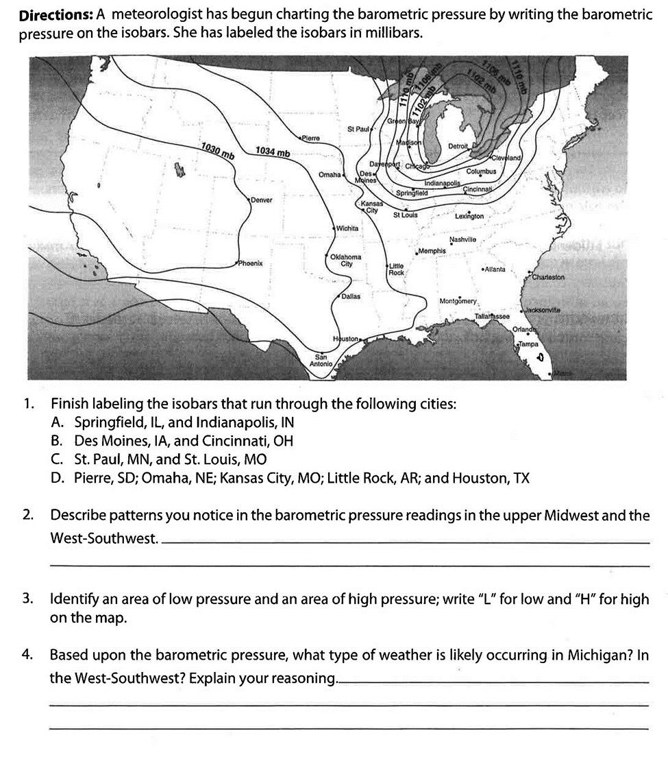

**Lesson Plan 4 : Pressure and Wind at Different Atmospheric Levels**

**Objectives:** What are the effects of the decrease in atmospheric pressure and altitude?

**Common Core Standards:** Pressure Differences, Force, Equalization, Structures and Properties of Matter.

E.7.9A Students will demonstrate an understanding of how complex changes in the movement and patterns of air and water molecules caused by the sun, winds, landforms, ocean temperatures, and currents in the atmosphere are major determinants of local and global weather patterns.

E.7.9A.1 Analyze and interpret weather patterns from various regions to differentiate between weather and climate.

E.7.9A.2 Analyze evidence to explain the weather conditions that result from the relationship between the movement of water and air masses.

E.8.9B.1 Research and map various types of natural hazards to determine their impact on society.

PHS.8.3 Relate thermal energy transfer to real world applications of conduction (e.g., quenching metals), convection (e.g., movement of air masses/weather/plate tectonics), and radiation (e.g., electromagnetic).

ESS.3.5 Analyze and interpret weather data using maps and global weather systems to explain and communicate the relationships among air masses, pressure systems, and frontal boundaries.

**Pacing:** Week Long (5) 45 minute lessons

**WARM UP:** What are the two main measurements used to describe wind?

**TEACH:**

What are the effects of the decrease in atmospheric pressure and altitude?

Most weather phenomena occur in the lowest level of the atmosphere, the troposphere, just below the stratosphere.

In general, air pressure and density decrease with altitude in the atmosphere. However, temperature has a more complicated profile with altitude, and may remain relatively constant or even increase with altitude in some regions (see the temperature section, below). Because the general pattern of the temperature/altitude profile, or lapse rate, is constant and measurable by means of instrumented balloon soundings, the temperature behavior provides a useful metric to distinguish atmospheric layers. In this way, Earth's atmosphere can be divided (called atmospheric stratification) into five main layers. Excluding the exosphere, the atmosphere has four primary layers, which are the troposphere, stratosphere, mesosphere, and thermosphere. From highest to lowest, the five main layers are:

Exosphere: 700 to 10,000 km (440 to 6,200 miles)

Thermosphere: 80 to 700 km (50 to 440 miles)

Mesosphere: 50 to 80 km (31 to 50 miles)

Stratosphere: 12 to 50 km (7 to 31 miles)

**Troposphere: 0 to 12 km (0 to 7 miles) 🡨 Most Weather Occurs Here**

Common Pressure Levels and Altitudes:

Level Altitude(ft) Altitude(m)

1000 MB 364 ft 111 m

925 MB 2,498 ft 762 m

850 MB 4,781 ft 1,458 m

700 MB 9,882 ft 3,013 m

500 MB 18,289 ft 5,576 m

400 MB 23,574 ft 7,187 m

300 MB 30,065 ft 9,166 m

250 MB 33,999 ft 10,366 m

200 MB 38,662 ft 11,787 m

**TEACH**

**Powerpoint Presentations**

**Alternate Opener: Using Twister.Com on classroom devices, observe current weather models for your region.**

**English (ESL) Language Development Multilingual Glossary**

**¡Llueve a cántaros! = Literally: "It's raining pitchers/buckets!"**

**¡Llueve a mares! = Literally: "It's raining oceans!"**

**If all that rain is getting you down (or if someone is simply having a hard time in life), this rain-phrase means "this too will pass":**

**Siempre que llovió, paró = Literally: "Whenever it rained, it stopped"**

**A couple of phrases when it's really cold:**

**¡Hace un frío que pela! = Literally: "It's so cold it burns your skin!"**

**¡Me estoy congelando! = Literally "I'm freezing!"**

**And when it's a little warmer...**

**¡Ay, qué calor!= Literally: "What heat!"**

**¡Es un horno! = Literally: "It's an oven!"**

**Cooperative Learning: Share your results with your neighbor while critiquing each other’s models and understanding. Understand that more eyes on a project make for a better outcome.**

**Communicating Concepts**

**Vocabulary Exercises:** Pressure Differences, Force, Equalization, Structures and Properties of Matter.

**PRACTICE AND APPLY**

**Pressure Lesson Plan 5 : 3D Representation of Pressure/Wind**

**Objectives:** Using Virtual Reality to Visualize Atmospheric Conditions and Phenomena to determine:

What is Pressure? What is Wind and how is it generated within large weather systems? How is wind related to atmospheric pressure? What determines the atmospheric pressure at a location? Is it the mass of air in the atmospheric column? Is it the density of the air? Is it the temperature of the air column? How is wind related to atmospheric pressure? How do we construct a pressure map from pressure measurements? What can we learn from this data? How are pressure and temperature patterns related? What are the effects of the decrease in atmospheric pressure and altitude?

**Common Core Standards:** Molecules, Pressure, Wind Pressure Differences, Force, Equalization, Structures and Properties of Matter. Pressure Maps, Isobars, High and Low Pressure. Color Scales, Pressure Scales, Distribution of Pressure Pattern Recognition, Contouring Pressure, Force, Balance of Forces, Equilibrium, Stability, Buoyancy, Weight, Buoyant Force.

E.7.9A Students will demonstrate an understanding of how complex changes in the movement and patterns of air and water molecules caused by the sun, winds, landforms, ocean temperatures, and currents in the atmosphere are major determinants of local and global weather patterns.

E.7.9A.1 Analyze and interpret weather patterns from various regions to differentiate between weather and climate.

E.7.9A.2 Analyze evidence to explain the weather conditions that result from the relationship between the movement of water and air masses.

E.8.9B.1 Research and map various types of natural hazards to determine their impact on society.

PHS.8.3 Relate thermal energy transfer to real world applications of conduction (e.g., quenching metals), convection (e.g., movement of air masses/weather/plate tectonics), and radiation (e.g., electromagnetic).

ESS.3.5 Analyze and interpret weather data using maps and global weather systems to explain and communicate the relationships among air masses, pressure systems, and frontal boundaries.

DA.1A.2b Students should be able to present data in various visual formats. For example, the data collected could be organized into two or more visualizations

DA.1A.3a Students should be able to analyze data in visual formats.

DA.1A.3b Students should be able to identify patterns and make predictions based on the patterns.

DA.2.2 Collect data using computational tools and transform the data to make it more useful and reliable.

DA.3A.3 Collect, transform, and organize data to help others better understand a problem. [COLLECTION, VISUALIZATION, & TRANSFORMATION] (P4.4)

DA.3A.3a Students should use various data collection techniques for different types of computational problems. For example, user surveys, mobile device GPS, social media data sets, etc.

DA.3A.3b Use computational tools to collect, transform, and organize data to help others better understand a problem.

DA.3A.3c Students should use data analysis to identify significant patterns in data sets.

AP.3A.6 Create artifacts by using procedures within a program, combinations of data and procedures, or independent but interrelated programs. [MODULARITY] (P5.2)

DA.3B.1 Use data analysis tools and techniques to identify patterns in data representing complex systems.

DA.3B.2 Select data collection tools and techniques to generate data sets that support a claim or communicate information. [COLLECTION, VISUALIZATION, & TRANSFORMATION] (P7.2)

DA.3B.3 Evaluate the ability of models and simulations to test and support the refinement of hypotheses. [INFERENCE & MODELS] (P4.4)

**Pacing:** Week Long (5) 45 minute lessons

**WARM UP: Using Twister.Com on classroom devices, observe current weather models for your region.**

**PRACTICE AND APPLY**